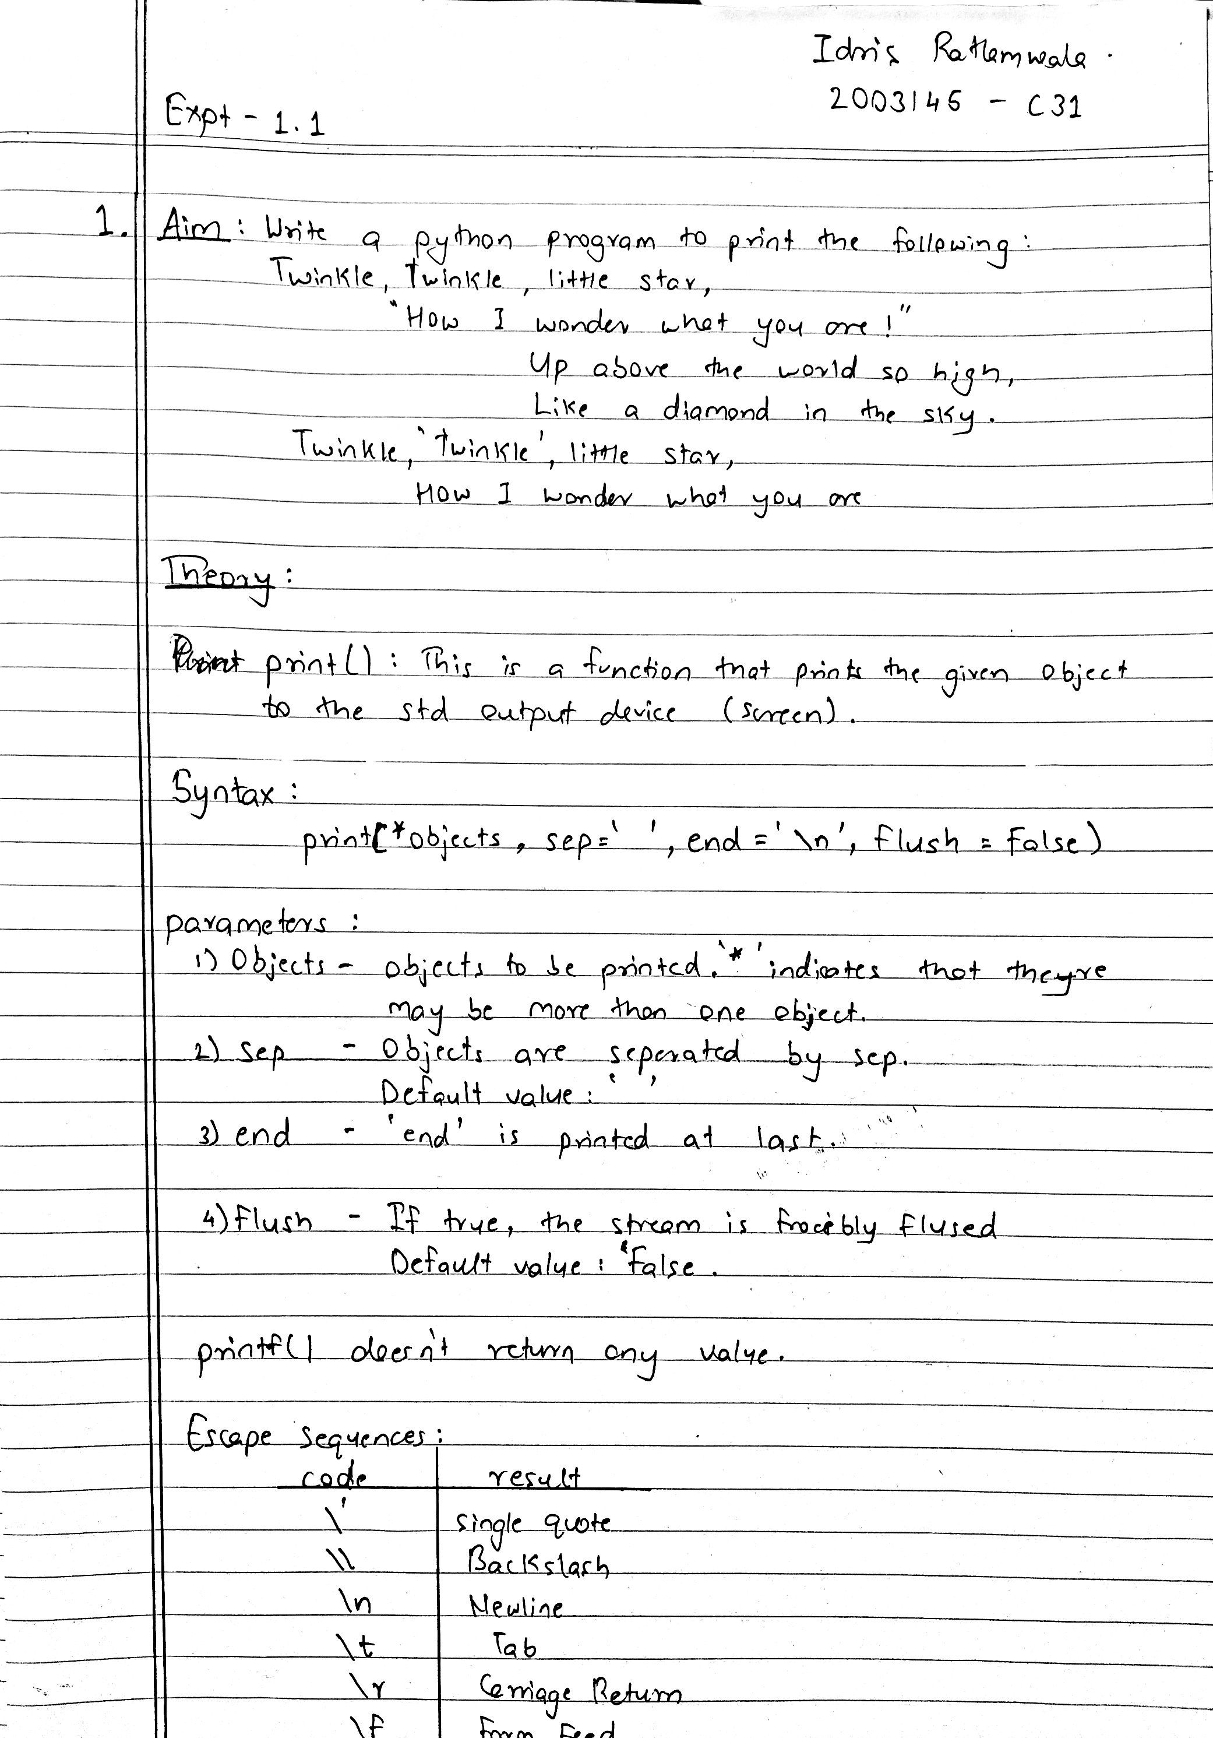

Program :

print('''Twinkle, twinkle, little star,\n\t"How I wonder what you are! "\n\t\tUp above the world so high,\n\t\tLike a diamond in the sky.\nTwinkle, ' twinkle ', little star,\n\tHow I wonder what you are''')

Output :

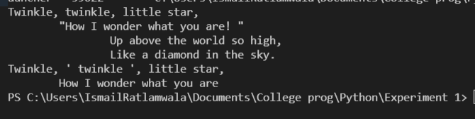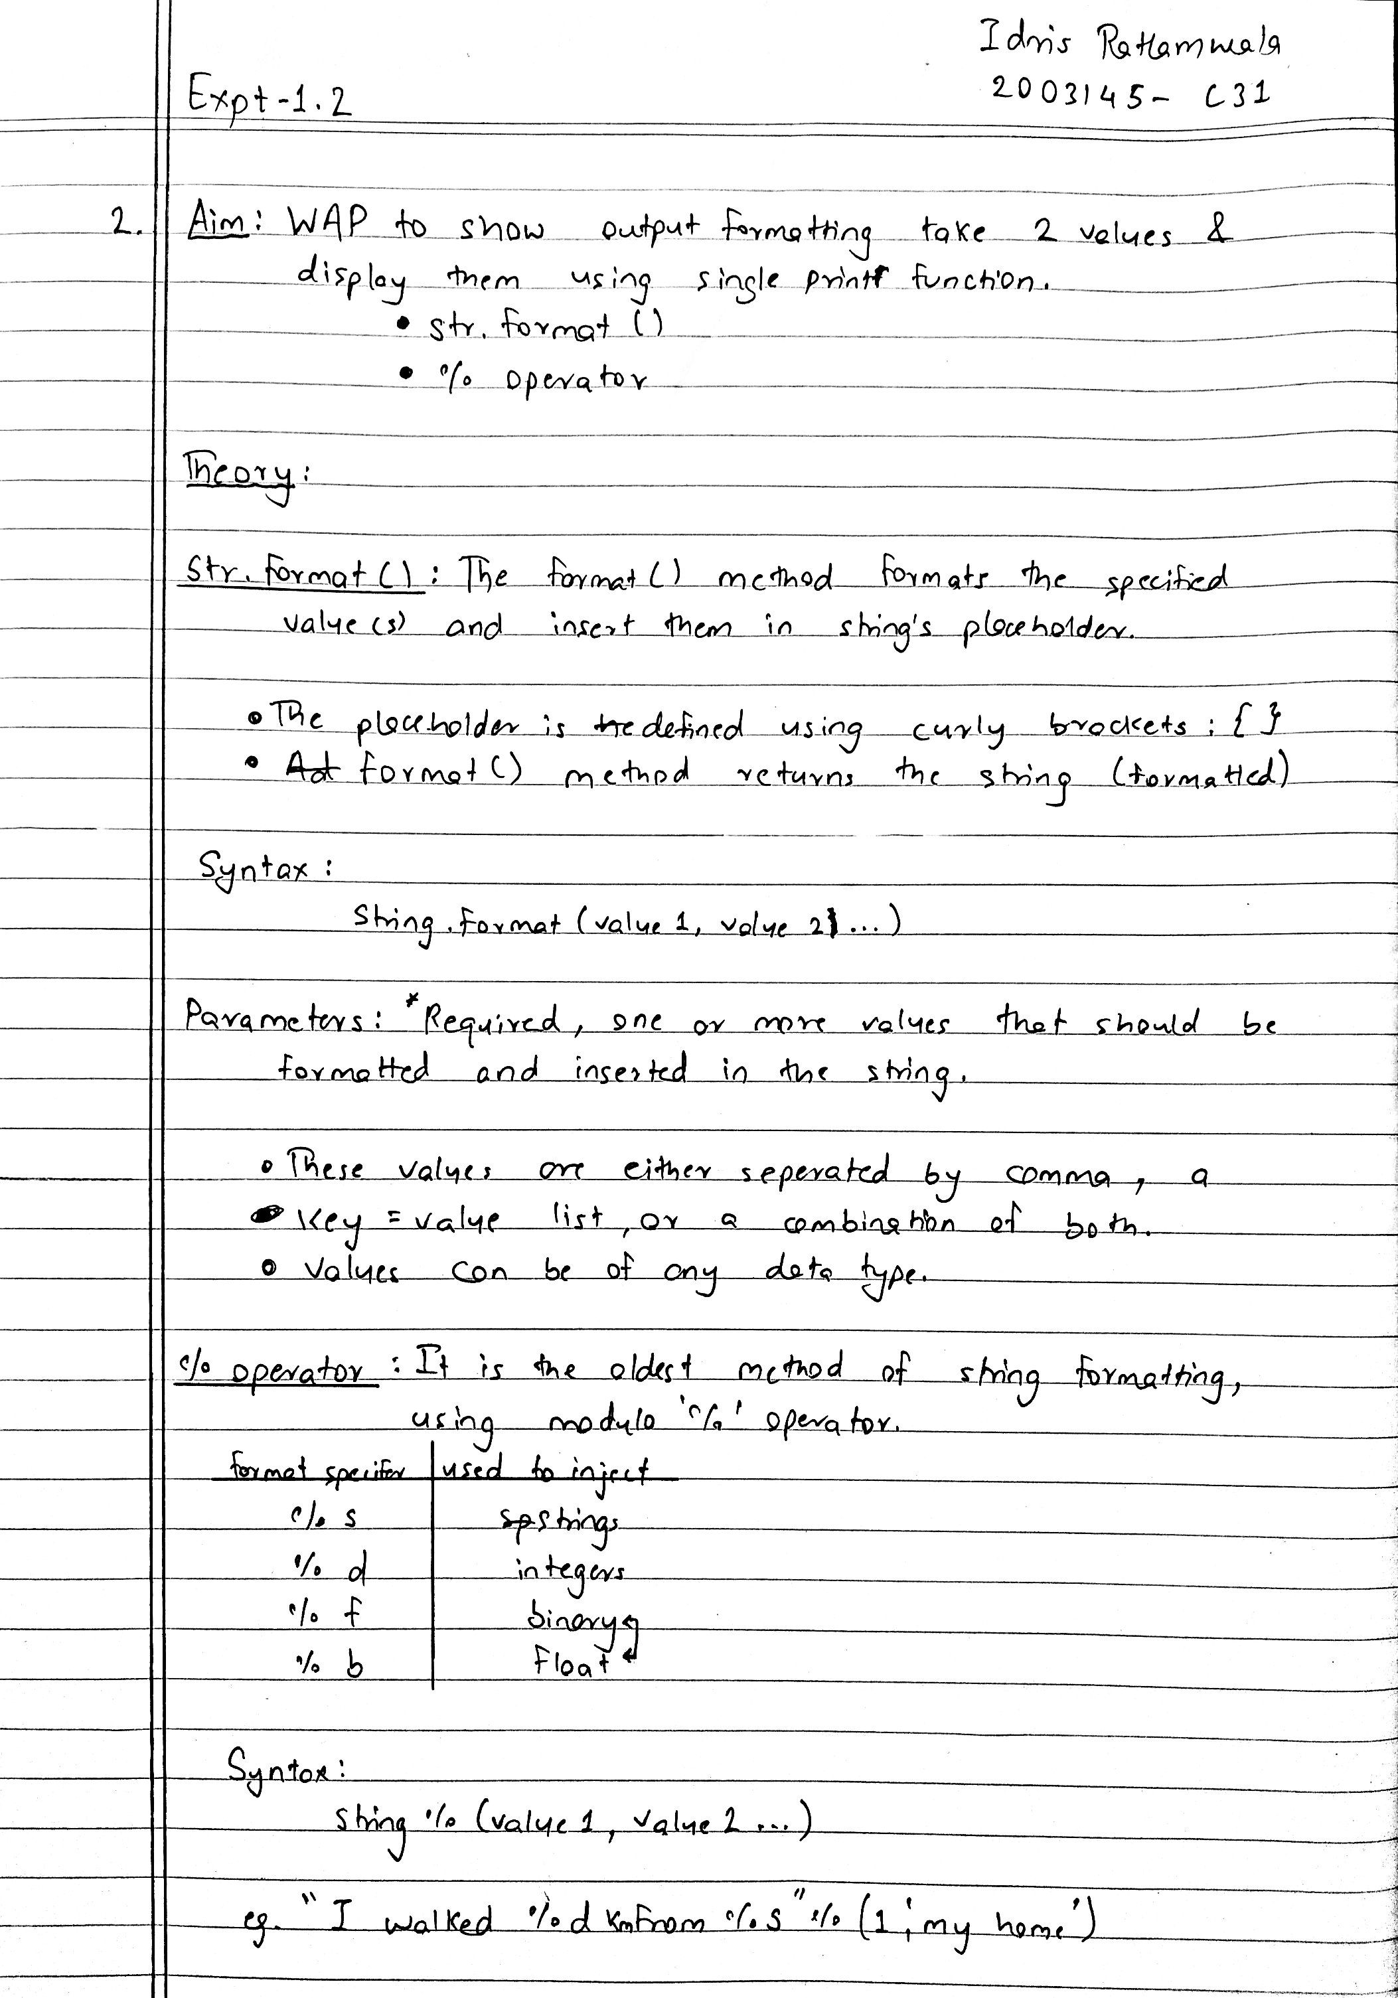

Program :

name = str(input("Enter your name : "))

age = int(input("Enter age : "))

print("""\nUsing str.format()

Your name is {}, you're {}\n""".format(name,age))

print("""Using modulo operator

Your name is %s, you're %d\n"""%(name,age)

Output :

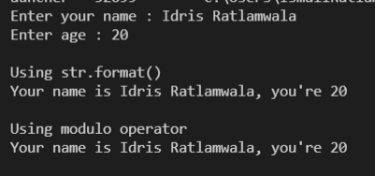

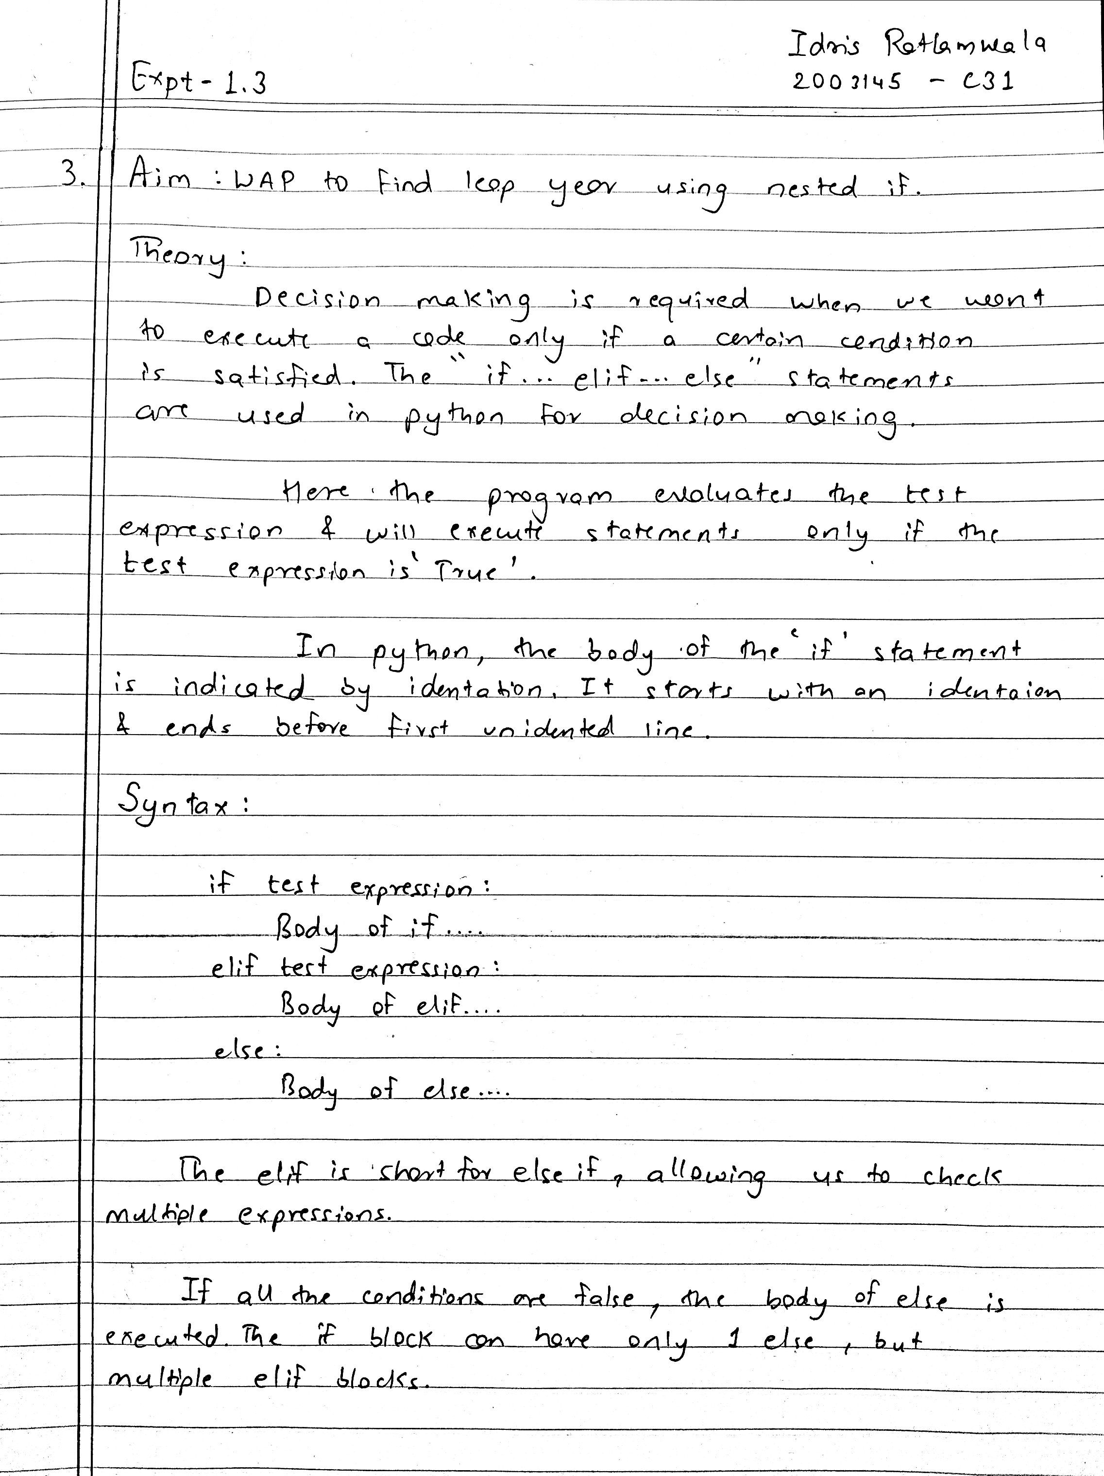

Program :

year = int(input("Enter the Year to be checked: "))

if(year % 4 == 0):

        if(year % 100 !=0):

            print("%d is a Leap Year" % year)

        else :

            if year % 400==0 :

                print("%d is a Leap Year" % year)

            else :

                print("%d is Not the Leap Year" % year)

else:

    print("%d is Not the Leap Year" % year)

Output :

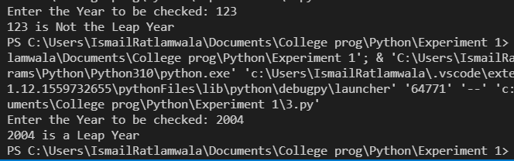

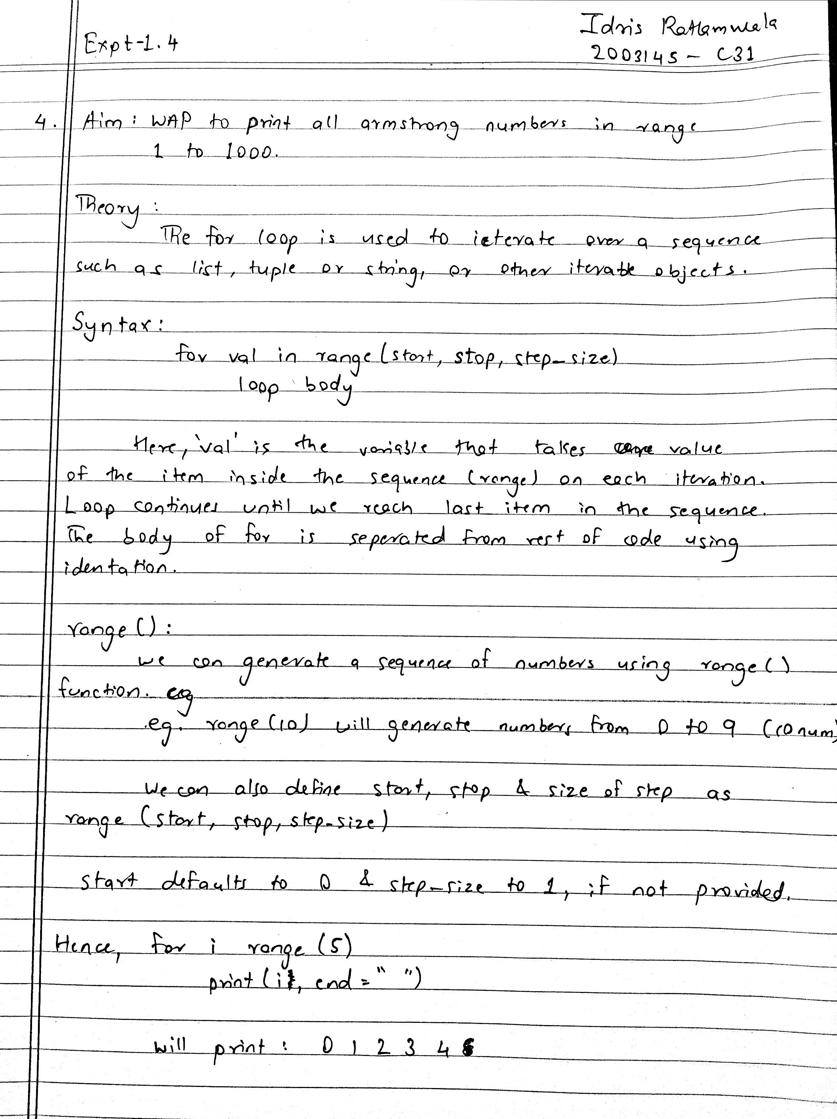

Program :

for num in range(1, 1001):

    n = len(str(num))

    sum = 0

    temp = num

    while temp > 0:

        digit = temp % 10

        sum += digit ** n

        temp = int(temp/10)

    if num == sum:

        print(num)

Output :

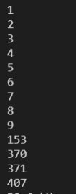

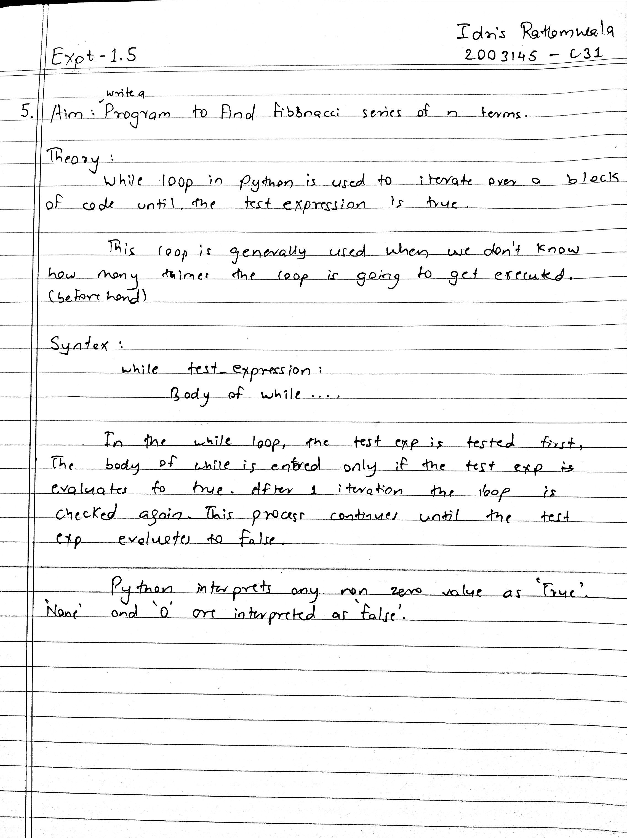

Program :

n = int(input("Enter the value of 'n': "))

a = 0

b = 1

sum = 0

count = 1

print("Fibonacci Series: ", end=" ")

while(count <= n):

    print(sum, end=" ")

    a = b

    b = sum

    sum = a + b

    count +=1

Output :

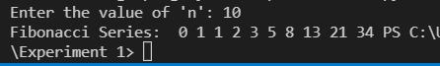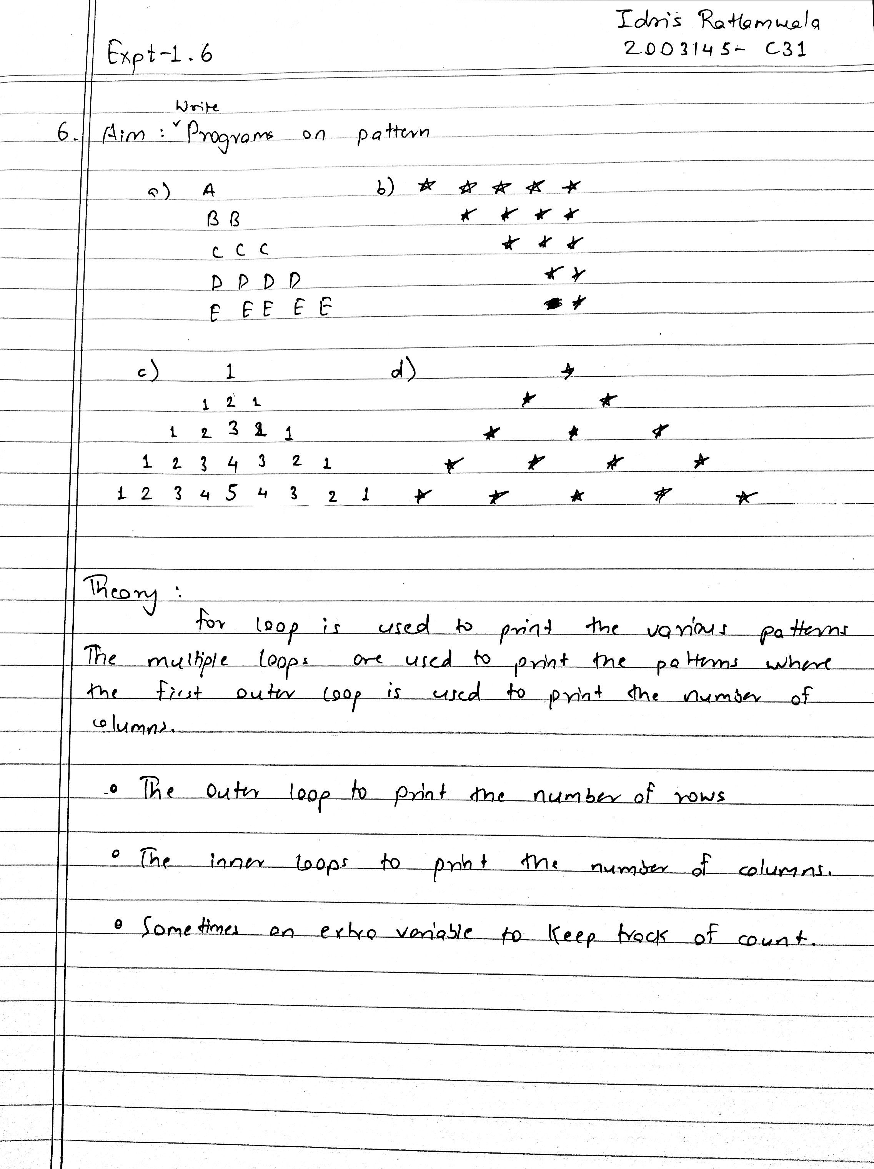

Program /Output **:**

A.

for i in range(5):

    for j in range(i+1):

        print(chr(i+65),end=" ")

    print()

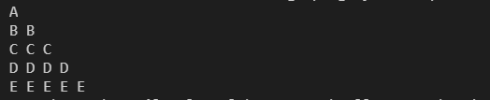

B.

for i in range(5):

    for j in range(i):

        print(end=" ")

    for j in range(5-i):

        print("*",end="")

    print()

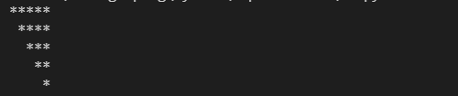

C.

for i in range(6):

    for j in range(5-i):

        print(end=" ")

    for j in range(i+1):

        print(j+1,end="")

    for j in range(i,0,-1):

        print(j,end="")

    print()

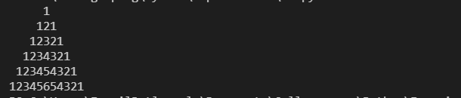

D.

for i in range(5):

    for j in range(5-i):

        print(end=" ")

    for j in range(i+1):

        print("* ",end="")

    print()

